SUMMERVILLE CREDIT UNION · CONSOLIDATED MEMBER GUIDE · CSUM-06 of 30
Move Money Hub

Module: nFinia Digital Banking > Move Money
Sources: Summerville Reports Series A (36 docs) + Series B (25 docs) | Features: nFinia Documentation Features Spreadsheet
01 PRODUCT SUMMARY

The Move Money Hub is the central launchpad for all payment and transfer activities within nFinia Digital Banking. From one consolidated screen, members can access Quick Pay (loan payments), Internal Transfers, transfers to other Credit Union members, external ACH transfers, FedNow Instant Pay, Zelle, Bill Pay, Wire Transfers, and more.
This hub eliminates navigation complexity by surfacing every money-movement option in a clear tile layout. Members identify the correct transfer type quickly and navigate directly to the appropriate workflow without searching through menus or sub-menus. The Move Money hub is also where Online Forms and Recipient Management are accessible.
For Summerville staff and power users, the hub also surfaces transfer templates, multi-payee transfer options, and business payment features under the same navigation node, making it the single entry point for all outgoing fund movements.

At a Glance

Attribute | Detail
Module | Move Money
Transfer Options | Quick Pay, Own Account, Other Members, External, FedNow, Zelle, Bill Pay, Wire
Recipient Management | Accessible from the Move Money hub
Online Forms | ACH, Wire, Address, Skip Pay forms accessible here
Business Features | Transfer templates, Multi-payee, ACH batch (business accounts)
Related Reports | CSUM-07–15 (all transfer/payment reports)

02 KEY USE CASES

Use Case | Who Uses It | What They Do | Business Value
Select Transfer Type | Members initiating any payment | View all payment options on one screen, select the matching tile | Reduces payment errors from navigating to the wrong workflow
Bill Pay Access | Members paying external bills | Click the Pay Bills tile to navigate to the bill payment service | One-click access to integrated bill pay from the central hub
Wire Transfer Initiation | Members sending a wire | Click the Wire Transfer tile to open the wire form | Direct access to domestic and international wire request forms
New Member Orientation | First-time digital banking users | Browse the Move Money hub to understand all available payment options | Lowers learning curve — all options visible in one location

03 STEP-BY-STEP GUIDE

Navigation: Dashboard > 'Move Money' in top navigation bar.

Step 1 — Start from Dashboard
The member begins at the Dashboard after logging in. The Dashboard displays all account balances, upcoming payments, quick-action tiles, and the top navigation bar with links to Accounts, Move Money, and More.
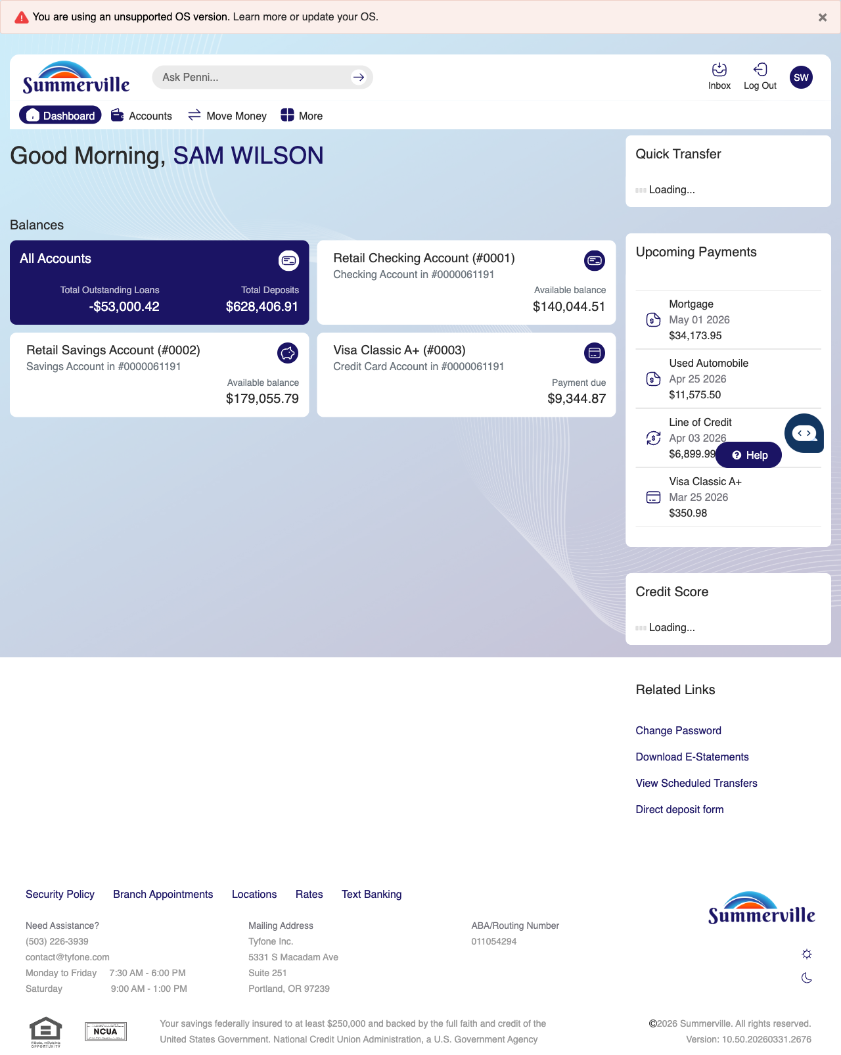
Step 1: Start from Dashboard

Step 2 — Navigate to Move Money Hub
The member clicks ‘Move Money’ in the top navigation bar. The Move Money Hub displays all payment and transfer options as tiles, including Pay Bills, Quick Pay, Zelle Payment, Internal Transfers, Other Members, Same-Day Transfers, Send Instantly, Manage Recipients, Add Recipient, Transaction History, Scheduled Transfers, and P2P Transfer.
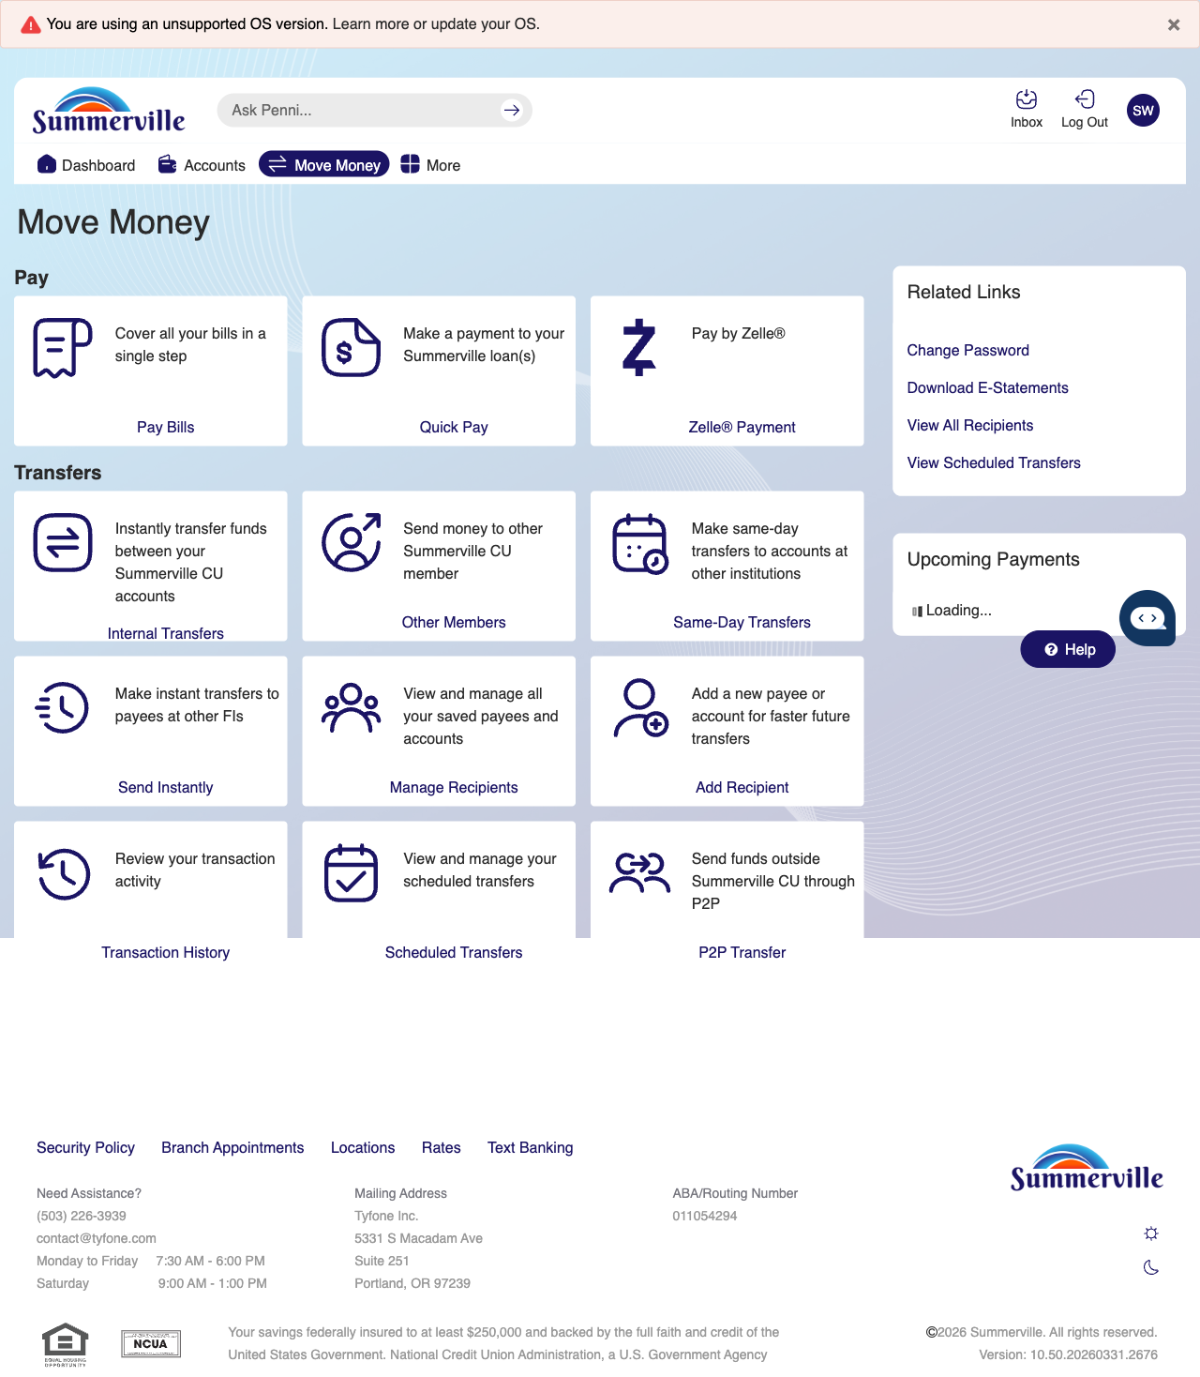
Step 2: Move Money Hub

Step 3 — Browse Payment Options & Bill Pay
The Move Money hub continues with the same grid layout of payment options. A promotional banner appears below the grid, and an upcoming payments section on the right shows account balances.
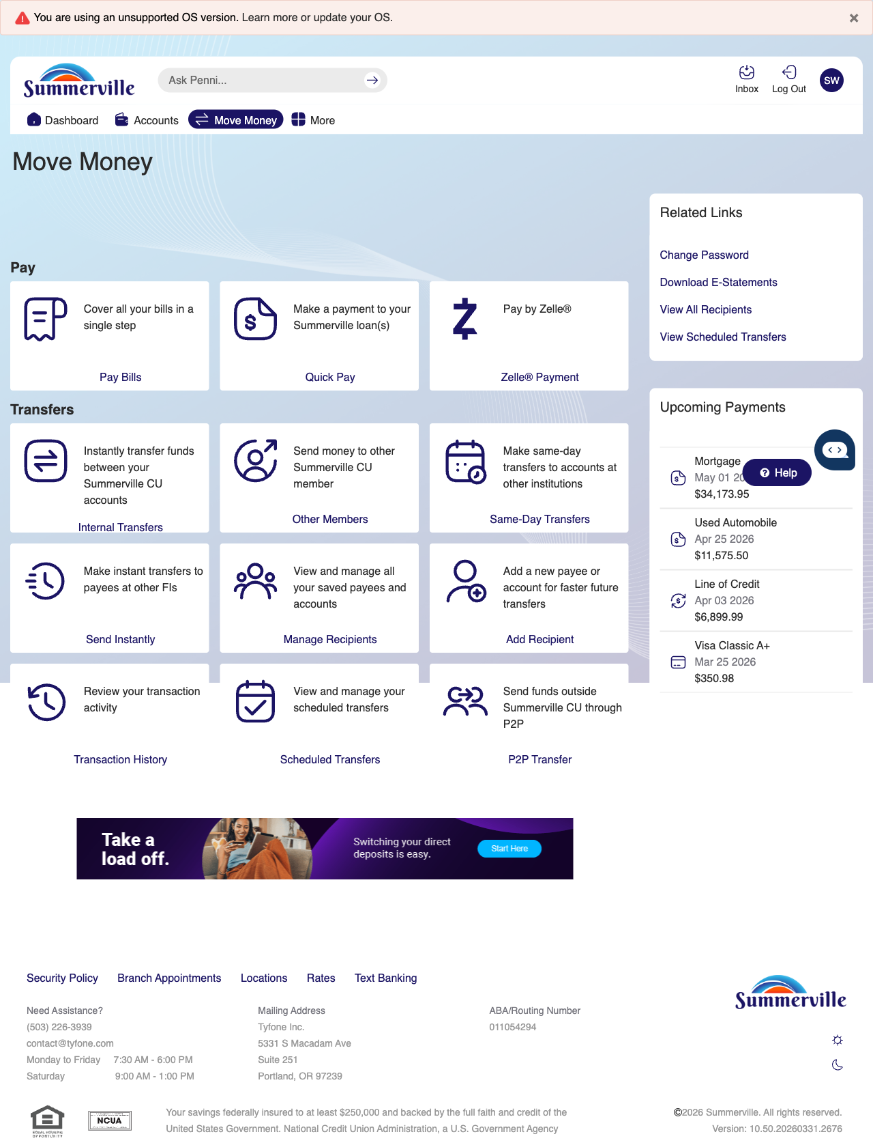
Step 3: Browse Payment Options & Bill Pay

